**PL/SQL**

**Exercise 1: Control Structures**

**Scenario 1:**

Question: Write a PL/SQL block that loops through all customers, checks their age, and if they are above 60, apply a 1% discount to their current loan interest rates.

BEGIN

FOR customer IN (

SELECT c.CustomerID, c.Name, l.LoanID, l.InterestRate

From Customer c

JOIN Loans l ON c.CustomerID = l.CustomerID

)

LOOP

IF MONTHS_BETWEEN(SYSDATE, customer.DOB)/12 > 60 THEN

UPDATE Loans

SET InterestRate=InterestRate-1

WHERE LoanID=customer.LoanID;

END IF;

END LOOP;

END;

**OUTPUT :**

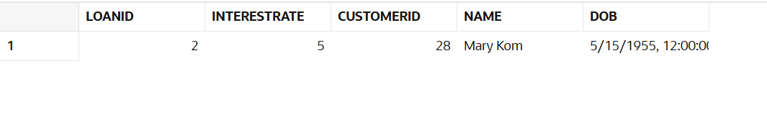

**Scenario 2:**

Question: Write a PL/SQL block that iterates through all customers and sets a flag IsVIP to TRUE for those with a balance over $10,000.

BEGIN

FOR customer IN (

SELECT CustomerID, Balance

FROM Customers

)

LOOP

IF customer.Balance > 10000 THEN

UPDATE Customers

SET IsVIP = ‘Yes’

WHERE CustomerID=customer.CustomerID ;

END IF;

END LOOP;

END;

**OUTPUT:**

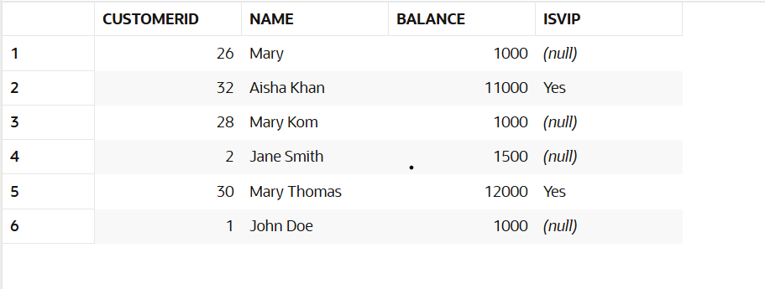

**Scenario 3:**

Question: Write a PL/SQL block that fetches all loans due in the next 30 days and prints a reminder message for each customer.

BEGIN

FOR customer IN (

SELECT c.CustomerID, l.EndDate, l.LoanAmount, l.LoanID

FROM Customers c

JOIN Loans l ON c.CustomerID=l.CustomerID

)

LOOP

IF MONTHS_BETWEEN(SYSDATE, customer.EndDate )=1 THEN

DBMS_OUTPUT.PUT_LINE(‘Reminder to pay loan’ || customer.CustomerID);

END IF;

END LOOP;

END;

**OUTPUT:**

